# Part B: Modular View Documentation:

## Section 1: Primary Presentation:

UML Modular View Diagram

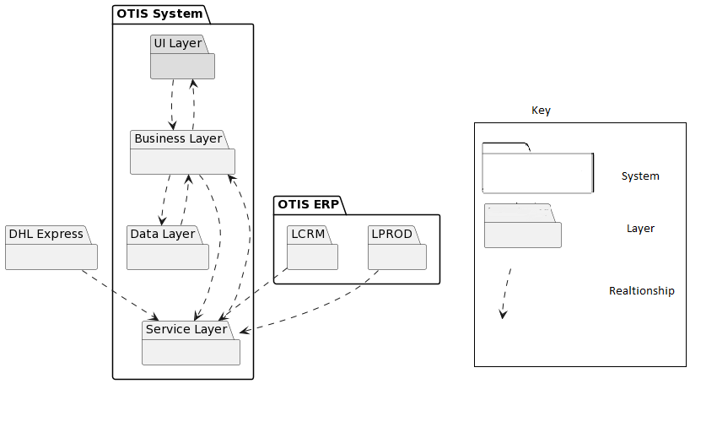

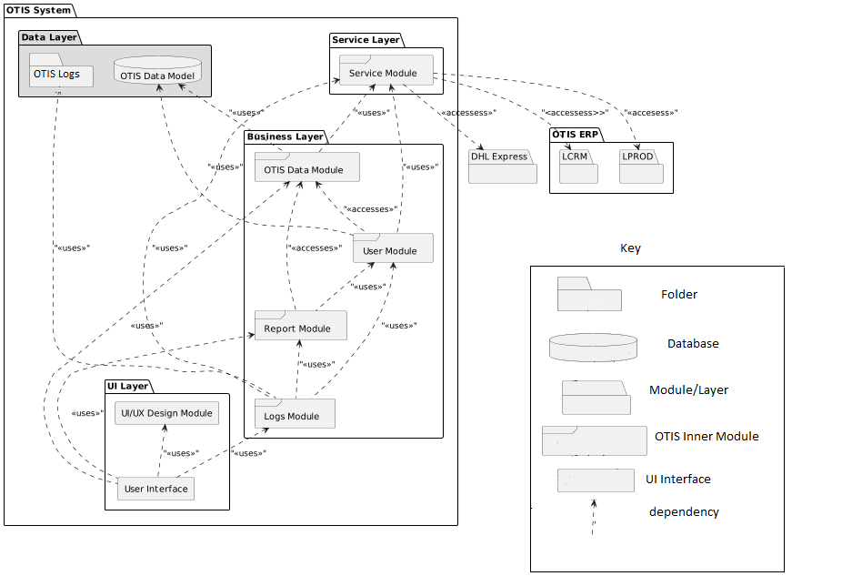

Uses view in Modular View

## Section 2: Element Catalogue:

### 2a): Elements and their properties:

Our system would consist of 4 layers in which the data is managed. The layers are listed below:

* OTIS Service
* Business Layer
* OTIS Data Model
* UI Layer

**OTIS Service:**

OTIS service consists of the module which has the responsibility to fetch data from the external system and provide data to the OTIS modules in the business layer. The layer consists of one module listed below:

|  |  |
| --- | --- |
| Element | Responsibility |
| Service Module | The Module would fetch data from the external system through required requests and provide data to the business layer of our System. When the user logs into the system, the system would authorize the user by getting the user details from the LCRM. The service module consists of triggers that automatically dump new data from the external systems to the OTIS system |

**Business Layer:**

Business layer of our system consist of module which consists OTIS changes in the system. Data storing, Data fetching, Data retrieval, system logs logic is written in the layer. The business layer consists of following modules:

|  |  |
| --- | --- |
| Element | Responsibility |
| Report Module | Consist of all different types of reports which user could download and view from the system. System can filter through parameters and give different format to the authorize user. |
| Logs Module | The logs are categorized into system logs, audit logs and event logs. Module get data from service, reports and user module to get all the events with timestamps in log file in the server. |
| OTIS Module | Get data from service module and store data in the OTIS database. It’s also provide the OTIS modules data which is needed by the user. |
| User Module | Stores data of different users and their authorization level in the system. Stores and retrieves data from the database and matches the authentication system by validating the given data. User access is also managed in the module |

**OTIS Data Model:**

Data Model consist of OTIS relation database and Otis Log files. The data model stores the incoming data from the modules and perform action through trigger, views queries.

|  |  |
| --- | --- |
| Element | Responsibility |
| OTIS Logs | Consist of folder of different logs of the system. OTIS Logs interact with the logs module and create edit logs files in the system. The logs data is also needed by authorized users to check the activity, error, event in the system |
| OTIS Database | Consist of Relational Database which stores and saves data. Data views, indexes are created in the database in order to get better performance |

**UI-Layer:**

UI Layer consists an interactive dashboard where users can see all their action they can perform. It consists of 2 elements

|  |  |
| --- | --- |
| Element | Responsibility |
| UI/UX module | UI/UX module consist of UI elements which is an open-source component used for user interface. It is used by the user interface |
| User Interface | User Interface is screens where users can interact with the system and perform actions. Each user type have different User interface |

### 2b): Relations and their properties:

|  |  |  |
| --- | --- | --- |
| Element | Relationship | Responsibility |
| Service Module | User Module uses Service Module | User module get data user data from Service Module. A automated call would generate from Service Module which get the data from external system |
| Logs Module uses Service Module | Each time Service Module dumps the data into the system, a log is being entered into the system |
| OTIS Module uses Service Module | External Systems (LPROD, DHL) is maintained in our system. Service module dumped data every 15 minutes |
| OTIS Data Model | OTIS Data Module uses OTIS Data Model | OTIS Data Module saves LCRM, LPROD, DHL Express data into OTIS Database through OTIS Data Model. New Data after 15 minute replaces the old data in the database |
| User module uses OTIS Data Model | After getting user data from LCRM, User Module authorizes and saves the data through OTIS Data Model. This OTIS User’s List is replaced after every week.  User module authorizes by giving authority by checking the user data from OTIS Database |
| OTIS Data Module | Report Module uses OTIS Data Module | Report Module get data from OTIS Module of LCRM, LPROD, DHL and generate a report according to provided Data |
| User Module uses OTIS Data Module | User Module get the LCRM, LRPOD and DHL data from OTIS Data Module and provides user with the data. |
| UI Dashboard Uses OTIS Data Module | UI checks the list of orders and their progress details through OTIS Data Module |
| Report Module | UI Dashboard uses Report Module | Authorized users from UI screen can generate report by providing the parameter and order list in the system |
| Logs Module uses Report Module | Every Report generate request by the user, log module create a log in the system |
| User Module | Log Module uses User Module | Every Time User request a login and view Data of their orders and track orders, a log through log module is created |
| Report Module uses User Module | User module uses User details from User Module and generates report |
| OTIS Logs | Logs Module Uses OTIS Logs | All OTIS logs from the modules are saved in OTIS Logs folder in server through Logs Module |
| UI Module | UI Dashboard uses UI Module | External styling components are used in Dashboard for good user experience. |
| Logs Module | UI Dashboard uses UI Module | System Admin checks the logs of the system and can check errors with timestamps |

### 2c): Element interfaces:

Our system is based on layered architecture and layers can different interfaces which talk with each other. Our system is Web Based and layers interact with each other using the HTTPS web as shown in figure. Service layer uses the HTTPS (JSON, XML) API of external system to fetch data which serves as a utility in our system. Our Business layer takes the data and deliver it into respective database using the ORM (Object Relationship Model). System users can view the data through a web browser by going to the provided route.

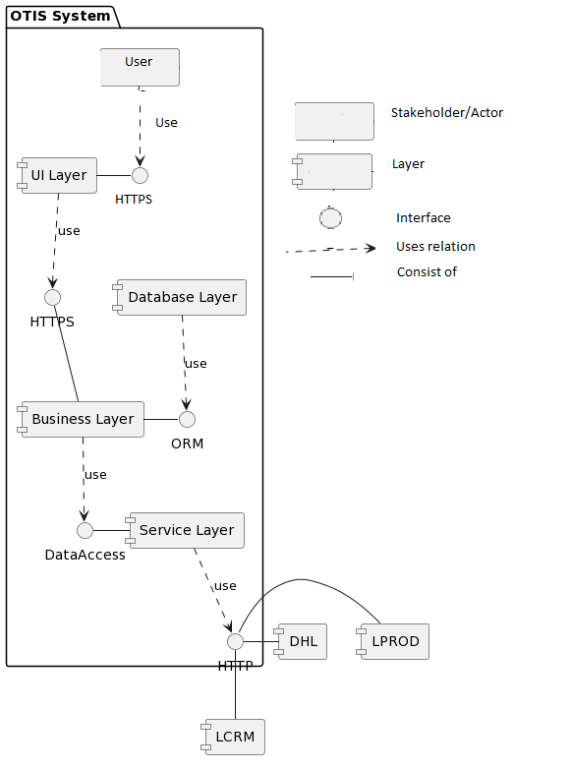

### 2d): Element Behavior:

Our application interacts with modules and database in order to handle the request from the user of the system. Our system is updated using an automated service through Service module. Service modules fetches data from external system and replaces the existing data from database through respective module functions. The behavior of 3 primary use cases of our system is shown through sequence diagram show below:

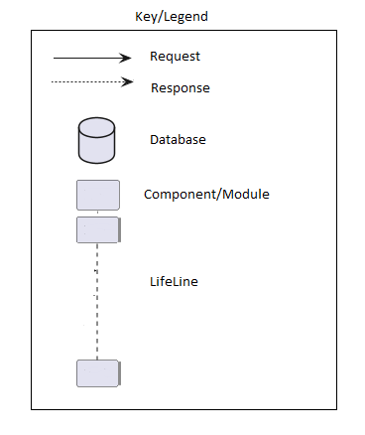

#### Sequence Diagrams:

**Use Case 1: Manage Customer Order Record**

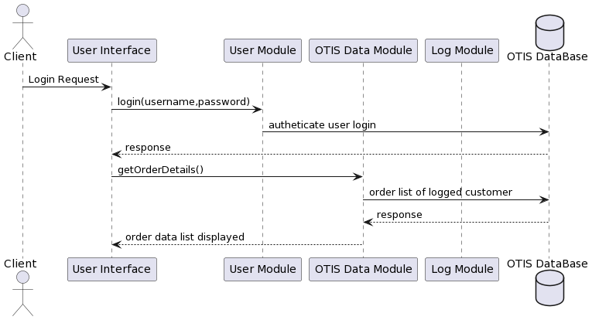

**Use Case 2: Generate Order Report**

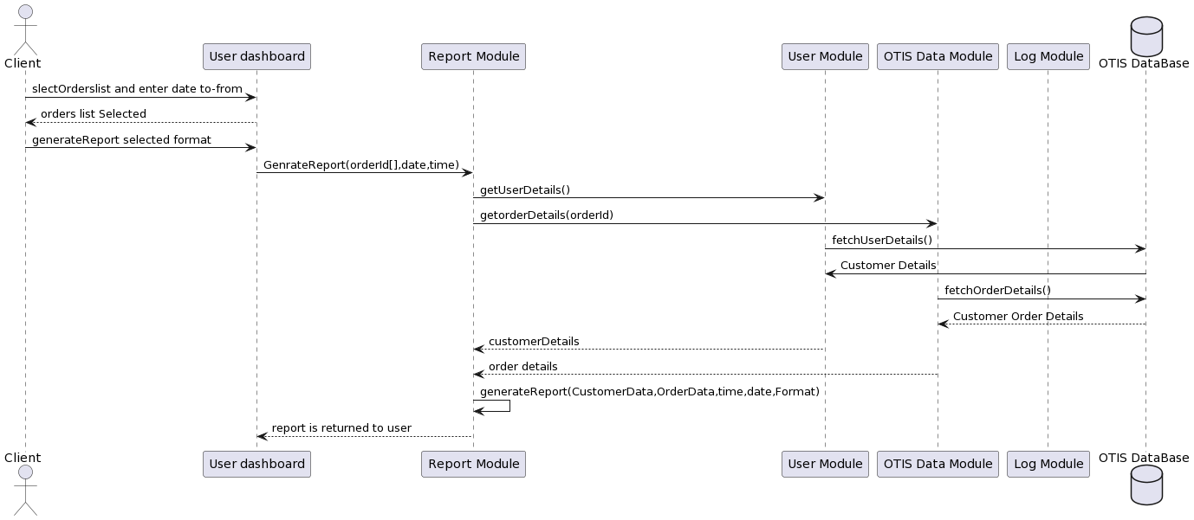

**Use Case 3: Track Order Record**

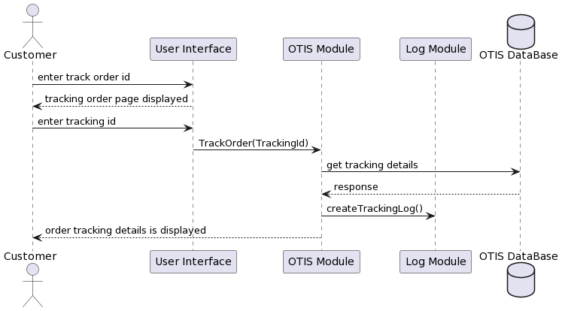

## Variability guide:

Lysia has more than 400 client spread all across Europe. As our data is coming from external system LCRM, LPROD and DHL express, our service module triggers an API call to the external system and get relative data and saves it into OTIS database.

|  |  |  |  |
| --- | --- | --- | --- |
| SR No. | Variability | Module | Rationale |
| 1 | An API call is generated to the relevant external system if data isn’t present in our data which is required | Service Module | If data isn’t present in the system, OTIS system needs to validate that the data is in sync with the external system data |
| 2 | If the external system data dump fails, the system provides the latest data from our database | OTIS Module, User Module | The system needs to displays user with the latest possible data if the external data dump causes an error. |
| 3 | If OTIS database fails, backup database is also maintained and used in operation | OTIS Database | If the database crashes/destroys accidently, the user order information must be backed up |
| 4 | UI/UX Module can be changed and external UI library can be used. All stakeholders have different | UI Layer | Using external UI library will help our developer team to implement as they are familiar with the UI components. |
| 5 | If the user order data is not updated latest to 30 min, system also provides user data with label “Legacy data” | OTIS Module | Will let the user know if the data is in-sync with the latest external system data. If the user queries and the system doesn’t present the same thing, user needs to get notified |

## Rationale:

#### Architectural Drivers:

|  |  |  |
| --- | --- | --- |
| Design Decision | Addresses | Rationale |
| Layered-oriented architecture: Separate layers in the system | QA2: Maintainability | As our main 3 quality attributes are performance, Maintainability and Availability. Given the conditions it will be easy to develop and maintain. As dependency is low, it addresses availability. Performance will be good as system would have less than 10000 users for now |
| Using Web Interface | Concerns C5 | Delivery time is 6 months. Our team is trained to build Web Apps |
| Create Separate Report Module in the system | UC2: Generate Order Report | Report record and report UI is created separately from the system. It increases cohesion and it would be easy to keep track of the reports generated and log management |
| Creation of a separate database | QA3: Availability | If the data is not provided by the external system, our system would fetch the latest data from database |
| Java Spring boot is used for selected TECH stack | Constrain C2 | Our team had experience in developing the system in Java spring boot. As we need to integrate the OTIS system with the external systems and system needs to be up and running in 6 months. |
| Logs management is done through a module and saved separately in the server as log files | UC6, UC5 | Logs Event, System and audit logs are saved and handled through a separate module and saved in log folder in server |
| Order detail and order tracking are fetched through the service and saved in the database through OTIS Module | UC3: Track Order Record | As external Systems (DHL, LPROD) provide us the data through JSON, the data is dumped every 30 minutes into the system. A database query would fetch the data to user. If the data is not present in the OTIS database, An API call would check in the external system and display the data if present. |
| If External system data dumping fails, the error is logged into system logs and the system admin is notified through email | QA1 : Performance | The data dumping fail meaning that our system has the data but the data is not updated with the system. So an Error message and notification needed to be generated in order to alert the system admin to fix the issue |
| Designed in layered Modular Architecture | QA2: Maintainability | As Performance and maintainability were our main Quality attributes, We decided to opt for an layered architecture |
| Increase Cohesion by separating modules which have different responsibility | QA2: Maintainability | Separating modules will increase cohesion in the system and it would be easy to test and maintain |
| Create Separate Module for Logs of all the system | Concern C9 | As the system have multiple layers and it would be easy to track the logs. If a system fails, our system logs are not affected |

#### Tactics: (Change tactics with the performance)

We as a team looked into the quality attributes, use cases, constraints and concerns implemented

|  |  |  |
| --- | --- | --- |
| Tactics | Tactics QA | Module Implemented |
| Create a database backup and update it weekly | Performance(Maintain multiple copies of Data) | Data Model(Data Layer) |
| Trigger data dump of users from LCRM once every 4 weeks | Performance(Manage Event Rate) | Service Module |
| Expectation handling is done if an error occurs in the generation of reports and alert is notified to System Admin | Maintainability(Fault Detection) | Report Module |
| If the database doesn’t have the required order tracking data, an API call is generated to the external system LPROD,DHL | Availability (State Resynchronization) | OTIS Module |
| System Administrator can view the error logs along with the timestamps and module | Availability (Expectation Detection) | Logs Module |
| Service module and Data Base server will be monitored and how well the system is performing | Availability (Conditional Monitoring) | Service Module, Database Server |
| Modules is split to increase the cohesion in the system | Maintainability (Split Module) | Business Layer |

#### Other Architectural Decisions:

|  |  |
| --- | --- |
| Decisions | Rationale |
| UI/UX module is used by the user interface in importing UI components | As there are multiple stakeholders in the system, there are multiple dashboard for the system. We pre-build UI/UX components |

## Part B: Component and Connector Documentation:

### Section 1: Primary Presentation:

UML Component and Connector Diagram

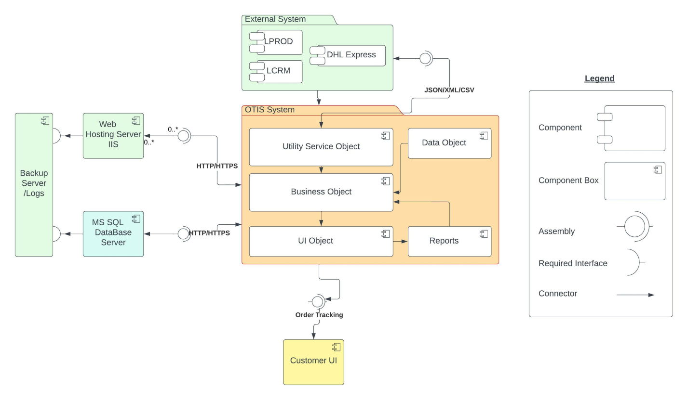

## Section 2: Element Catalogue:

### 2a): Elements and their properties:

Our OTIS system would consist of multiple components in which the data is interact with each other at run time via component and connector structure. The C&C are listed below:

* OTIS System Component
  + Utility Service Object
  + Business Object
  + UI Object
  + Data Object
  + Reports
* External system Component
  + DHL Express
  + LCRM
  + LPROD
* Web Hosting Component
  + Internet information Services (IIS)
* Database Server Component
  + Microsoft SQL Server (Ver.15.0)
* Backup Server /Log Server component
  + Log Server
* Customer UI Component
  + Customer UI

#### OTIS System Component

The main component and connector structure is OTIS System (Component) which consist of five different component interact with each other and depend on every modules in OTIS main component. It’s also interacting with external system, databases component and web hosting component. Below are details description/ responsibility of each component.

|  |  |
| --- | --- |
| Component | Responsibility |
| Utility Service Object | This service utility work continuously extracting the data from external components. The utility service object fetches data from the external system through requests and provides data to the business layer of our System and data stored on database. When the user logs into the system, the system would authorize the user by getting the user details from the database updated user profile via LCRM user lists. The service module consists of service constantly working as background service for extracting data. |
| Business Object | Business Object (Component) of our system consist of multiple interaction component which consists OTIS all business object / business rule has been written in the system. Data storing, Data fetching, Data retrieval, system logs logic is written in the component. This component has main responsibility to connect all other components like data module, reports, service object and UI objects. |
| UI Object | UI Object component consist of UI elements which is an open-source component used for user interface. It is used by the user after login to the system by authentication methods. Its consist of multi level UI/UX with fully responsive web pages. Has main dashboard as landing page where user can view partial views to look many other UI of components. |
| Data Object | The data object component is consist has many classes for data structure used by ORM (object relational model). Also has many other custom model used by business object component. |
| Report | The report component consists of all different types of reports. Has separate module for users so user could download and view from the system. System can filter data through parameters and give different format to the authorize user. |

#### External Services Component:

External system component handle all component external component to interact and provide ETL (extract, transform, load)/data as (JSON/XML) from the external system (component) to the utility service object in OTIS system where the data has stored in database. The utility component consists of three module listed below:

|  |  |
| --- | --- |
| Component | Responsibility |
| External Services Component | This external services component work continuously extracting the data from external components like LCRM, DHL Express, LPROD. The utility service object fetches data from the external system through requests and provides data to the utility service object and data stored on database. When the user logs into the system, the system would authorize the user by getting the user details from the database updated user profile via LCRM user lists. the external service module consists of scheduler service constantly working as background service for extracting data. |

#### Web Hosting Component:

The web hosting component of OTIS system consist of IIS (internet information service ) which deployed on web hosting component of hosting server. Used to manage and handling request from OTIS main component . handle web load balancing , HTTP / HTTPS certifications etc.

|  |  |
| --- | --- |
| Element | Responsibility |
| Web Hosting component | The web hosting component responsible for web application web hosting via IIS and other web hosting services. It can manage http and https certificates and different security certification for web hosting. Its work locally of Lycia environment but also on public access by public IPs. |

#### Database Server Component:

The database server component of OTIS system consists of MS SQL server 2019 (release 15.0).the server has capability to store large amount of data with backup facility to stored data on backup server.

|  |  |
| --- | --- |
| Element | Responsibility |
| Database Server component | The database server component responsible for storing data in relational database. It can manage and store large amount of external system data, user information, and product tracking information. Also has capability to stored file data on db server.  . |

#### Backup Server Component:

The backup server component of OTIS system consists of db server and file server for storing and backup database files in case of failure of system and in any component failure. The server has also stored log of system. The backup server has capability to store large amount of data.

|  |  |
| --- | --- |
| Element | Responsibility |
| Backup Server Component | The backup server component responsible for backup data via RAID (redundant array of independent disks) used to storing data either in system logs and database backup. It can manage and store large amount of external system data, user information, and product tracking information. The backup server component has log services for store event logs / user exception logs and other logs. |

#### Customer UI Component:

The customer UI component consists of interactive dashboard where users can see all their action they can perform. Handle lots of view for tracking order getting daily reports and extract details of order products.

|  |  |
| --- | --- |
| Element | Responsibility |
| Customer UI Component | The customer UI component module consists of UI elements which is an web based interactive UI used for user interaction. It is used after user authenticated by system and user see their screens and performs actions. Different company has various type of screens according to requirement assign by system admin team. |

### 2b): Relations and their properties:

|  |  |  |
| --- | --- | --- |
| Element | Relationship | Responsibility |
| Business object Component | External System Component | The business object component get data from external system component .A automated utility service extract data and generate ETL from utility component. |
| UI object | Every time when User request from UI object the system would be get data from database and provide data in UI response. |
| Reports | The reports module used to generate report. As system extract data from external system and generate reports via different filter applied on system. |
| Data object component | Data object component uses business object component | The data object component interacts with business objects via ORM for mapping of database tables also support custom classes for mapping multiple tables. |
| Utility service component | Business object component | The component use to interact with business logic written in Business object to store data on database server |
|  | External service component | The external service component used to extract data services from LCRM , DHL Express, LPROD and push to utility service component for data storing on database |
| Report | UI Object component uses Report Module | After authentication users from customer UI screen/ UI interface can generate report by providing the parameter and track order reports in the system. |
| Logs Module uses Report Module | Every Report generate request by the user, log module create a log in the system |
| UI Object Component | Customer UI Component | From customer UI component user request to login and view Data of their orders and track orders, a log through log module. |
| Report component uses User UI component | User module uses User details from User Module and generates report provide reports to other users . download reports in various format like pdf and xls. |
| Logs component | Logs Module Uses business object component | All OTIS logs from the modules are saved via business logic written in OTIS database and share backup folder on backup server |
| External system component | External system component uses utility services | External system component has services for fetch data from LCRM, LPROD, and DHL express to push in utility service component from storing data on database. |
| Web hosting component | Web hosting component uses main OTIS component | The web hosting component has interacted with OTIS main Component hosting via IIS. |
| Database server component | Database server component uses main OTIS component | The database server component used to save data from business object component (OTIS main component). |
| Backup server Component | Backup server component uses database / web hosting server component | The backup server component uses database and web hosting server component for backup database and log files. |

### 2c): Element interfaces:

OTIS is based on Layered based architecture but has services to interact with each component. The interface is mainly interact with other components of system. There are five interfaces for the system. The system would develop from local machine of developers to a staging site and finally integrated to production site on production web hosting server. There are below component worked with each other for interaction of system

1. External System
2. Main Dashboard User Interface
3. Customer UI
4. Web Server
5. DB Server
6. Backup Server

System has many interfaces depending upon the authorization level given to each module and user respectively. Every interface depending on other required interface. Below diagram showing how interface work on OTIS system.

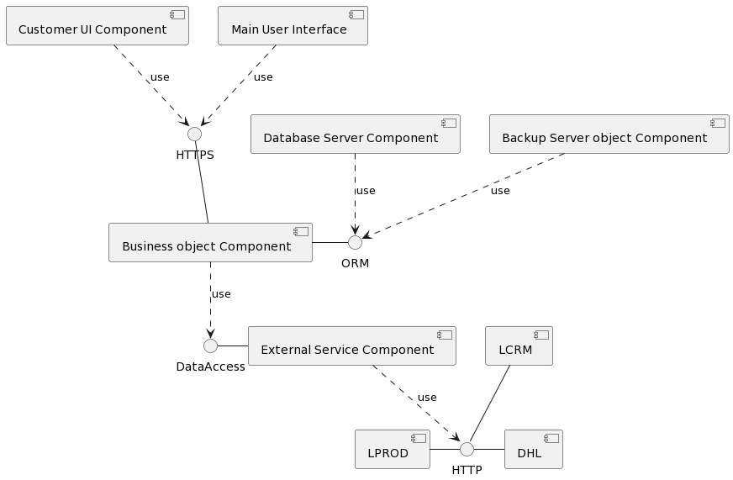

Interface Diagram

### 2d): Element Behavior:

The OTIS application interacts with each component via user interface and business object component in order to handle the request from the user of the system. The system shall extract the data from external services component and then stored on database server. The external system utility, as scheduler services that trigger on every 10 minutes to update the database according to new data available from system. The system shall using web hooks on LCRM and LPROD system to update regularly. The behavior of 3 primary use cases of our system is shown through sequence diagram show below:

Key/ Legend:



#### Sequence Diagrams:

Use Case 1:

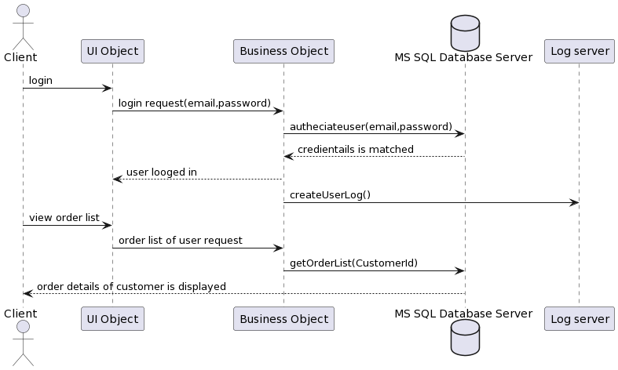

#### Use Case 2:

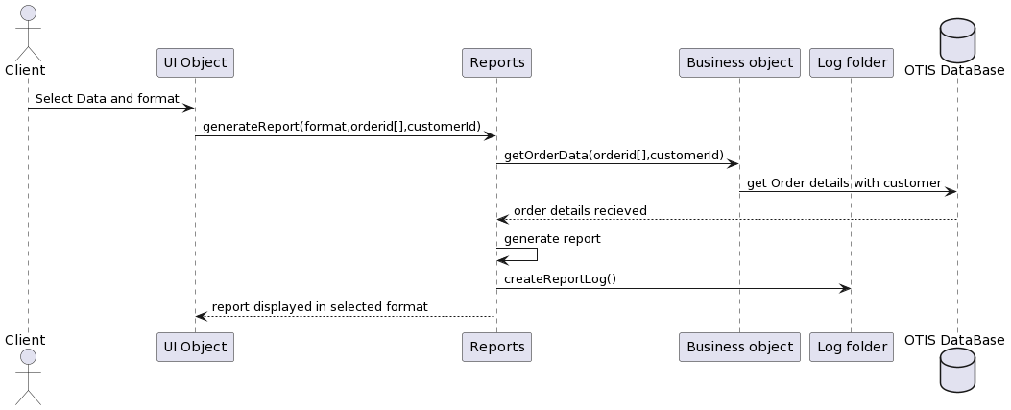

#### Use Case 3:

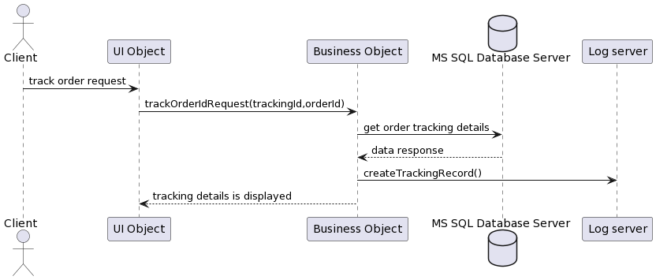

## Variability guide:

The system shall design as a large scale system which has component approach so when a component needed we use to connect a component on business object component as the system has been design to extract the data from any external system either new module is coming that directly integrated to external system and create business objects on OTIS system.it is relatively good approach for getting integrated any module to the system in future either its web service or any other data services.

|  |  |  |  |
| --- | --- | --- | --- |
| SR No. | Variability | Module | Rationale |
| 1 | An Hook call trigger on every 1 minutes for getting data from LPROD,DHL Express and LCRM objects | External Service Module | If data call fails to get data or any service failure then data is validate again for another call if error found persistently then system should trigger to write log on log file server. on other case if no new data is not found then system should not trigger to update anything on database |
| 2 | If the system data dump failure then the system display previous data only depend upon last update from last database | OTIS main Component Module, Business object Component | The system shall always show the latest updated data whenever new data updated. In case of any backend services failure the system shall display last updated records not affected on system. |
| 3 | In case of OTIS database service failure then backup RAID Service provide service with latest database backup. | OTIS Database Component | The system shall working normally incase of production database crash or service abundant. backup service start on immediate basis. |
| 4 | The Customer UI component/pages is capable to assign according to roles and rights. | UI Object Component | The admin will changes and assign different pages according to role and rights assign to customer UI. |
| 5 | If customer track an order but data is not found or upload on server so default massage has been display on notification menu | OTIS main Component | The system shall let the user about the sync data via default response message via response mapping table |

## Rationale:

#### Architectural Drivers:

Missing working on it